 | 10/4 | 10/5 | 10/6 | 10/7 | 10/8
Message | The COVID vaccines do not use a live virus and cannot give you COVID. Protect yourself and your loved ones, and get vaccinated today. #nashvilletakesoncovid | Children can get and spread COVID just like adults. Learn more about what we know about the differences between children and adult illness with COVID: #nashvilletakesoncovid | Only about half (53%) of adults in Davidson County are fully vaccinated against COVID. If you’re still waiting, it’s time to get vaccinated. Call 1-800-232-0233 to find a vaccine location nearest you. Watch this video to learn more: #nashvilletakesoncovid | We now have data from over 150 million Americans that tell us about the safety of COVID vaccines. Getting vaccinated is fast, free, and it works well to prevent against serious illness and death. #nashvilletakesoncovid | Are you looking to start the conversation about COVID-19 vaccines with someone who still has questions? Watch this video to learn more about starting a difficult conversation about vaccines with someone you know. #NashvilleTakesOnCovid
Video URL or or image | 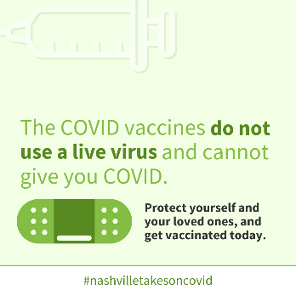 | Does COVID affect kids the same as adults?  https://youtu.be/DFY9elbXeeQ | Why it’s time to get the COVID vaccine  https://youtu.be/YnM_pcw0slk | 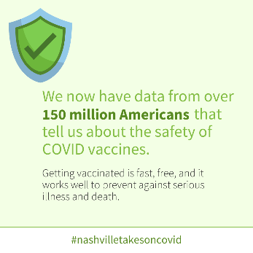 | What can I say to someone who is reluctant to get the COVID vaccine?  https://youtu.be/SgZtmLPK_KY

Nashville takes on covid Week 3 social media content English

